**PRIOR KNOWLEDGE**

|  |  |
| --- | --- |
| Team ID | PNT2022TMID09881 |
| Project Name | A Novel Method for Handwritten Digit  Recognition System |

# The prior knowledge on the below concepts should be acquired:

**1. MACHINE LEARNING:**

By providing data and information to computers without explicit programming, machine learning is the science of getting them to learn and behave like humans.

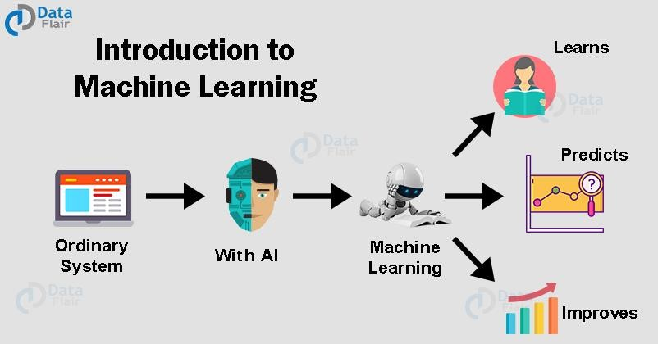

# Types of Machine Learning:

1. Supervised Machine Learning
2. Unsupervised Machine Learning
3. Reinforcement Learning

Semi-Supervised learning is used in Text Classification.

**1. Supervised Learning:**

In supervised learning, a model is able to predict with the help of labeled dataset. Itis based on supervision. It means in the supervised learning technique, we train the machines using the "labelled" dataset, and based on the training, the machine predicts the output. Here, the labelled data specifies that some of the inputs are already mapped to the output. More preciously, we can say; first, we train the machine with the input and corresponding output, and then we ask the machine to predict the output using the test dataset.

**Types:**

1. Classification
2. Regression

1. **Classification:**

Classification algorithms are used to solve the classification problems in which the output variable is categorical, such as "**Yes" or No, Male or Female, Red or Blue, etc**. The classification algorithms predict the categories present in the dataset. Some real-world examples of classification algorithms are **Spam Detection, Email filtering, etc.**

1. **Regression:**

Regression algorithms are used to solve regression problems in which there is a linear relationship between input and output variables. These are used to predict continuous output variables, such as market trends, weather prediction, etc.

**2. Unsupervised learning:**

Unsupervised Learning is different from the Supervised learning technique; as its name suggests, there is no need for supervision. It means, in unsupervised

machine learning, the machine is trained using the unlabeled dataset, and the machine predicts the output without any supervision.

**Types:**

1. clustering
2. Association

**a) Clustering:**

The method of dividing the objects into clusters which are similar between them and are dissimilar to the objects belonging to another cluster. **b) Association:**

Discovering the probability of the co-occurrence of items in a collection.

# 2.CLUSTERING, CLASSIFICATION AND REGRESSION

**Clustering:**

Clustering is an unsupervised technique. With clustering, the algorithm tries to find a pattern in data sets without labels associated with it. This could be a clustering of buying behavior of customers. Features for this would be the household income, age and clusters of different consumers could then be built.

**Classification:**

In contrast to clustering, classification is a supervised technique. Classification algorithms look at existing data and predicts what a new data belongs to.

Classification is used for spam for years now and these algorithms are more or less mature in classifying something as spam or not. With machine data, it could be used to predict a material quality by several known parameters such as humidity, strength, color, etc. The output of the material prediction would then be the quality.

**Regression:**

Regression is often confused with clustering, but it is still different from it.

With a regression, no classified labels (such as good or bad, spam or not spam, …) are predicted. Instead, regression outputs continuous, often unbound, numbers.

This makes it useful for financial prediction.

# 3.ARTIFICIAL NEURAL NETWORKS:

Artificial neural networks, more commonly referred to as neural networks or neural nets, are computer architectures that draw inspiration from the biological neural networks seen in animal brains. Artificial neurons, which are a set of interconnected units or nodes that loosely resemble the neurons in a biological brain, are the foundation of an ANN.

**Type of Neural networks:**

* Perceptron.
* Feed Forward Neural Network.
* Multilayer Perceptron.
* Convolutional Neural Network.
* Radial Basis Functional Neural Network.
* Recurrent Neural Network.
* LSTM – Long Short-Term Memory.
* Sequence to Sequence Models.

## 4. CONVOLUTIONAL NEURAL NETWORKS:

Due to its capacity to spot patterns in images, a convolutional neural network (CNN) is a type of artificial neural network that is mostly used for image recognition and processing. Although a CNN is a powerful tool, its training process necessitates millions of tagged data points.

**Layers of CNN:**

The different layers of a CNN. There are four types of layers for a convolutional neural network: the convolutional layer, the pooling layer, the RLU correction layer and the fully-connected layer.

**Components of CNN:**

1. Input layer
2. Output layer
3. One or more hidden layer

## 5. FLASK:

Python-based Flask is a microweb framework. Due to the fact that it doesn't require any specific tools or libraries, it is categorised as a microframework. It lacks any component where previous third-party libraries would normally perform standardised functions, such as a database abstraction layer, form validation, or other.

**WSGI:**

A straightforward calling convention called the Web Server Gateway Interface allows web servers to send requests to web apps or frameworks created in the Python programming language.

**Jinja2:**

A contemporary templating language for Python developers is called Jinja2. It was created using the Django template. It is used to produce markup languages such as HTML, XML, and others that are delivered to the user via an HTTP request.